LAB-EQUIPMENT 1 - BY .jkkisororongo

ELIZA READER MACHINE

Fundamental Principles
Enzyme-linked Immunosorbent Assays (ELISAs) combine the specificity of antibodies with the sensitivity of simple enzyme assays, by using antibodies or antigens coupled to an easily-assayed enzyme. ELISAs can provide a useful measurement of antigen or antibody concentration.
There are two main variations on this method: The ELISA can be used to detect the presence of antigens that are recognized by an antibody or it can be used to test for antibodies that recognize an antigen.
The micro plate reader also known as “Photometric micro-plate reader or ELISA reader”
Is a specialized spectrophotometer designed to read results of the ELISA test, a technique used to determine the presence of antibodies or specific antigens in samples.
The technique is based on the detection of an antigen or antibodies captured on a solid surface using direct or secondary, labeled antibodies; producing a reaction whose product can be read by the spectrophotometer.
The word ELISA is the acronym for “Enzyme-Linked Immunosorbent Assay”.
This chapter covers the use of micro plate readers for ELISA testing. For additional information on the instrument principles of operation and maintenance,

ELIZAREADER- (INTRODUCTION).
ELISA has been used as a diagnostic tool in medicine, plant pathology, and biotechnology, as well as a quality control check in various industries.
In the simplest form of an ELISA, antigens from the sample are attached to a surface.
Then, a matching antibody is applied over the surface so it can bind to the antigen.
This antibody is linked to an enzyme, and in the final step, a substance containing the enzyme's substrate is added. The subsequent reaction produces a detectable signal, most commonly a color change.
Performing an ELISA involves at least one antibody with specificity for a particular antigen. The sample with an unknown amount of antigen is immobilized on a solid support (usually a polystyrene micro titer plate) either non-specifically (via adsorption to the surface) or specifically (via capture by another antibody specific to the same antigen, in a "sandwich" ELISA).
After the antigen is immobilized, the detection antibody is added, forming a complex with the antigen. The detection antibody can be covalently linked to an enzyme or can itself be detected by a secondary antibody that is linked to an enzyme through bio conjugation.
Between each step, the plate is typically washed with a mild detergent solution to remove any proteins or antibodies that are non-specifically bound.
After the final wash step, the plate is developed by adding an enzymatic substrate to produce a visible signal, which indicates the quantity of antigen in the sample.
Note: ELISA can perform other forms of ligand binding assays instead of strictly "immuno" assays, though the name carried the original "immuno" because of the common use and history of development of this method.
The technique essentially requires any ligating reagent that can be immobilized on the solid phase along with a detection reagent that will bind specifically and use an enzyme to generate a signal that can be properly quantified. In between the washes, only the ligand and its specific binding counterparts remain specifically bound or "immunosorbed" by antigen-antibody interactions to the solid phase, while the nonspecific or unbound components are washed away.
Unlike other spectrophotometric wet lab assay formats where the same reaction well (e.g., a cuvette) can be reused after washing
The ELISA plates have the reaction products immunosorbed on the solid phase, which is part of the plate, and so are not easily reusable.

A general ELISA is a five-step procedure as follows;
1) coat the micro titer plate wells with antigen
2) block all unbound sites to prevent false positive results
3) add primary antibody (e.g. rabbit monoclonal antibody) to the wells
4) add secondary antibody conjugated to an enzyme (e.g. anti-mouse IgG)
5) reaction of a substrate with the enzyme to produce a colored product, thus indicating a positive reaction.
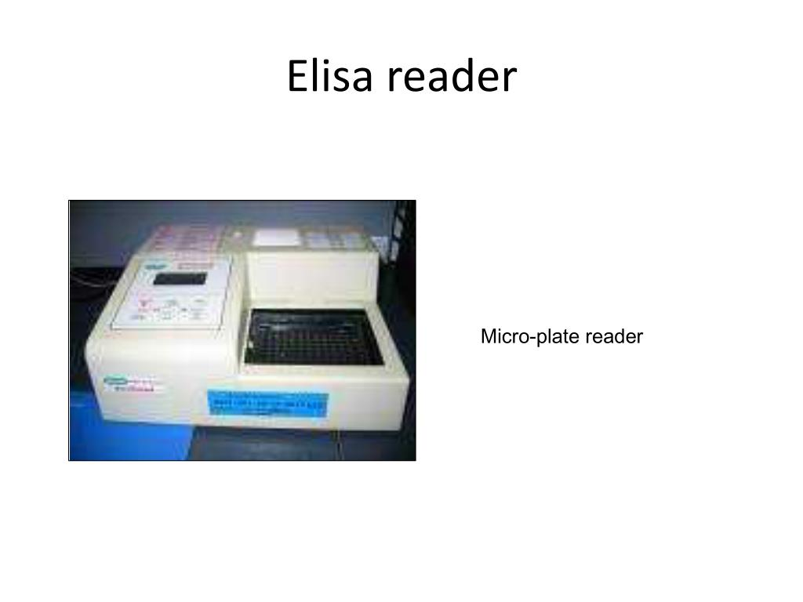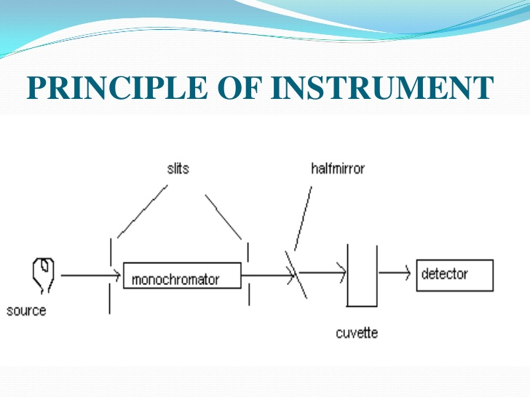
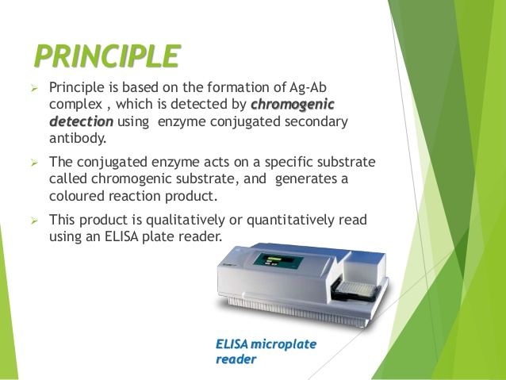

SUMMARY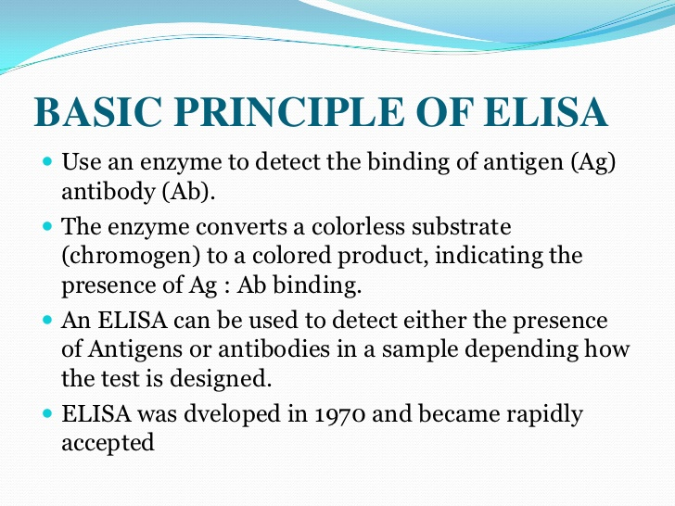DETAILED NOTES ON PRINCIPLE OF OPERATION
OPERATION PRINCIPLES
The micro plate reader is a specialized spectrophotometer. Unlike the conventional spectrophotometer which facilitates readings on a wide range of wavelengths, the micro plate reader has filters or diffraction gratings that limit the wavelength range to that used in ELISA, generally between 400 to 750 nm (nanometers).
Some readers operate in the ultraviolet range and carry out analyses between 340 to 700 nm. The optical system exploited by many manufacturers uses optic fibers to supply light to the micro plate wells containing the samples.
The light beam, passing through the sample has a diameter ranging between 1 to 3 mm. A detection system detects the light coming from the sample, amplifies the signal and determines the sample’s absorbance.
A reading system converts it into data allowing the test result interpretation. Some micro plate readers use double beam light systems. Test samples are located in specially designed plates with a specific number of wells where the procedure or test is carried out. Plates of 8 columns by 12 rows with a total of 96 wells are common.
There are also plates with a greater number of wells. For specialized applications, the current trend is to increase the number of wells (384-well plates) to reduce the amount of reagents and samples used and a greater throughput.
The location of the optical sensors of the micro plate reader varies depending on the manufacturers; these can be located above the sample plate, or directly underneath the plate’s wells.
Nowadays micro plate readers have controls regulated by microprocessors connection interfaces to information systems; quality and process control programs, which by means of a computer, allow complete test automation
Additional information.
As an analytical biochemistry assay and a "wet lab" technique, ELISA involves detection of an analyte (i.e., the specific substance whose presence is being quantitatively or qualitatively analyzed) in a liquid sample by a method that continues to use liquid reagents during the analysis (i.e., controlled sequence of biochemical reactions that will generate a signal which can be easily quantified and interpreted as a measure of the amount of analyte in the sample) that stays liquid and remains inside a reaction chamber or well needed to keep the reactants contained
This is in opposition to "dry lab" techniques that use dry strips. Even if the sample is liquid (e.g., a measured small drop), the final detection step in "dry" analysis involves reading of a dried strip by methods such as reflectometry and does not need a reaction containment chamber to prevent spillover or mixing between samples.
As a heterogenous assay, ELISA separates some component of the analytical reaction mixture by adsorbing certain components onto a solid phase which is physically immobilized. In ELISA
A liquid sample is added onto a stationary solid phase with special binding properties and is followed by multiple liquid reagents that are sequentially added, incubated, and washed, followed by some optical change (e.g., color development by the product of an enzymatic reaction) in the final liquid in the well from which the quantity of the analyte is measured.
The quantitative "reading" is usually based on detection of intensity of transmitted light by spectrophotometry, which involves quantitation of transmission of some specific wavelength of light through the liquid (as well as the transparent bottom of the well in the multiple-well plate format).
The sensitivity of detection depends on amplification of the signal during the analytic reactions. Since enzyme reactions are very well known amplification processes, the signal is generated by enzymes which are linked to the detection reagents in fixed proportions to allow accurate quantification, and thus the name "enzyme-linked.
The analyte is also called the ligand because it will specifically bind or ligate to a detection reagent, thus ELISA falls under the bigger category of ligand binding assays.
The ligand-specific binding reagent is "immobilized" i.e.usually coated and dried onto the transparent bottom and sometimes also side wall of a well(the stationary "solid phase" or solid substrate" here as opposed to solid micro particle/beads that can be washed away), which is usually constructed as a multiple-well plate known as the "ELISA plate." Conventionally, like other forms of immunoassays, the specificity of antigen-antibody type reaction is used because it is easy to raise an antibody specifically against an antigen in bulk as a reagent. Alternatively, if the analyte itself is an antibody, its target antigen can be used as the binding reagent
REPAIR/MAINTENANCE OF ELIZA MACHINE
INSTALLATION REQUIREMENTS
In order for the micro plate reader to operate correctly, the following points need to be respected
1. A clean, dust free environment.
2. A stable work table away from equipment that vibrates (centrifuges, agitators). It should be of a suitable size so that there is working space at the side of the micro plate reader.
The required complementary equipment for conducting the technique described above is: washer, incubator, dispenser and computer with its peripheral attachments.
3. An electrical supply source, which complies with the country’s norms and standards. In the country like America for example, 110 V and 60 Hertz frequencies is generally used, whereas other regions of the World use 220-240V, 50/60HZ.

ROUTINE MAINTENANCE
Maintenance described next focuses exclusively on the micro plate reader.
Basic maintenance Frequency:
Daily
1. Review that optical sensors of each channel are clean. If dirt is detected, clean the surface of the windows of the light emitters and the sensors with a small brush.
2. Confirm that the lighting system is clean.
3. Verify that the reader’s calibration is adequate. When the daily operations begin, let the reader warm up for 30 minutes. Next, do a blank reading and then read a full plate of substrate. The readings must be identical. If not, invert the plate and repeat the reading in order to determine if the deviation originated in the plate or the reader.
4. Examine the automatic drawer sliding system. It must be smooth and constant.
Preventive maintenance
Frequency:
Quarterly
- Verify the stability of the lamp.
- Use the calibration plate, conducting readings with intervals of 30 minutes with the same plate. Compare readings. There must be no differences.
- Clean the detectors’ optical systems and the lighting systems.
- Clean the plate drawer.
- Verify the alignment of each well with the light emission and detection systems.

Calibration of the micro plate reader
The calibration of a micro plate reader is a specialized process which must be executed by a technician or trained engineer following the instructions provided by each manufacturer.
In order to do the calibration, it is necessary to have a set of grey filters mounted on a plate of equal geometric size to those used in the analyses.
Manufacturers provide these calibration plates for any wavelength the equipment uses. Calibration plates are equipped with at least three pre-established optic density values within the measurement ranges; low, medium, and high value.
In order to perform the calibration, follow this process:
1. Place the calibration plate on the equipment.
2. Carry out a complete reading with the calibration plate. Verify if there are differences in the readings obtained from well to well. If this is the case, invert the plate (180°) and repeat the reading to rule out that differences are attributed to the plate itself.
In general, it is accepted that the instrument does not need further calibration if the plate results are as expected at two wavelengths.
3. Verify if the reader requires calibration. If so, proceed with the calibration following the routine outlined by the manufacturer, verifying that the reading’s linearity is maintained as rigorously as possible.
4. If the instrument does not have a calibration plate, verify it by placing a coloured solution in the wells of a plate and immediately carry out a complete reading.
Then invert the plate 180° and read the plate again. If both readings display identical, average values in each row, the reader is calibrated.
Common Problems on Eliza Reader Machine and How to Solve
Problem1
The reader gives a reading that does not make sense.
Remedy
The illumination lamp is out of service.
Replace the lamp with one with the same characteristics as the original.
Problem 2
The reader’s readings vary from row to row.
Remedy
Dirty optical sensors. Clean the sensors.
The illumination system’s lenses or parts are dirty.
Clean the lighting system’s lenses.
Lack of calibration in one or more channels.
Verify the calibration of each one of the channels.

Problem 3
The reader displays high absorbance values.
Remedy
Reagents expired and/or incorrectly prepared. Check to see if the TMB is colourless and the preparation adequate.
Contamination with other samples.
Repeat the test verifying the labeling, the washer and how the pipette was used.
Incorrect wavelength filter.
Verify the recommended wavelength for the test.
Adjust if it is incorrect.
Insufficient or inefficient washing.
Verify the washing method used.
Use an appropriate quality control test.
Very long incubation time or very high temperature.
Check incubation times and temperatures.
Incorrect sample dilution.
Check process for sample dilution.
Some reagent was omitted.
Verify that the test has been carried out according to the established procedure

Problem 4
The reader displays low absorbance values.
Remedy
Very short incubation time and very low temperature.
Check temperatures and incubation times.
The reagents were not at room temperature. Check that the reagents are stable at room temperature.
Excessive washing of the plate.
Adjust the washing process to what the test manufacturers indicate.
Incorrect wavelength filter.
Verify the wavelength selected.
Use wavelength recommended for the test.
Expired or incorrectly prepared reagents.
Check the used reagents.
Test the dilutions.
A reagent was omitted.
Verify that the test was done according to the established procedure.
The plate displays scratches at the bottom of the wells.
Prepare a new plate and repeat the test.
Incorrect selected or dirty plate.
Verify the type of plate used.
Prepare a new plate and repeat the test.
The plate wells have dried up.
Change the manner in which the plate is washed.
The plate is incorrectly placed or is seated unevenly in the reader.
Check the placement of the plate. Repeat the reading.
Humidity or fingerprints on the outer part of the bottom of the plate. Verify that the plate under the bottom of the wells is clean.
Residual quantities of washing buffer in the wells before adding the substrate.
Confirm that the washing buffer is completely removed.
The substrate tablets do not dissolve completely.
Verify that the tablets dissolve correctly.
The substrate tablet has been contaminated by humidity or metal clips or is not complete.
Test the integrity and handling of substrate tablets.
The position of the blank well could have been changed and an incorrect quantity has been subtracted at each reading.
Verify that the plate set-up is colored
Problem5
The reader displays unexpected variation in the optical density readings.
Remedy
The reader’s lamp is unstable.
Replace the lamp with one that has similar characteristics as the original.
Problem 6
Misaligned light beam.
The reader was transferred or moved without using the necessary precautions.
Remedy
Call the specialized service technician.
The light source – lamp – has been changed and the replacement has not been installed or aligned correctly.
Verify its assembly and alignment.
Read more on maintenance of Eliza reader machine……………….
END
Thank you- By Joel Keidza Kisorongo

